***Assignment -3***

***Andrew John***

***18BEC1278***

* **Develop a code to upload the water tank level and light intensity values to the IBM IoT platform and visualize them in the web application.**

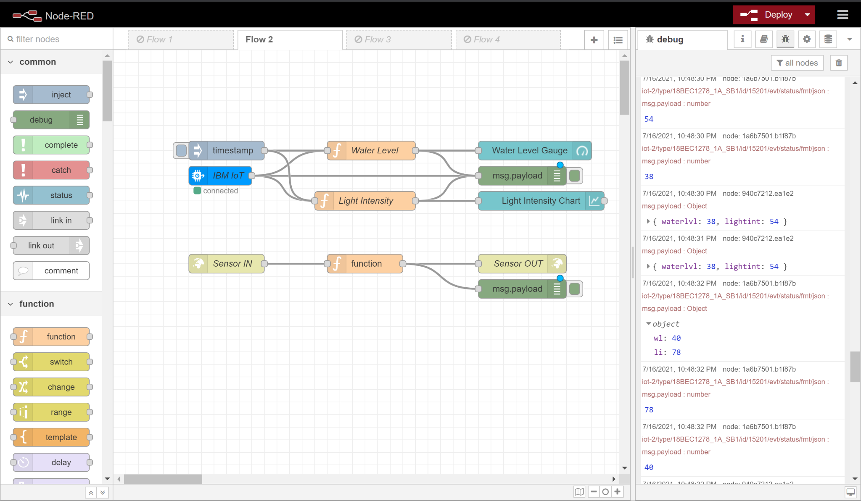

*Fig-1: Node-RED flow*

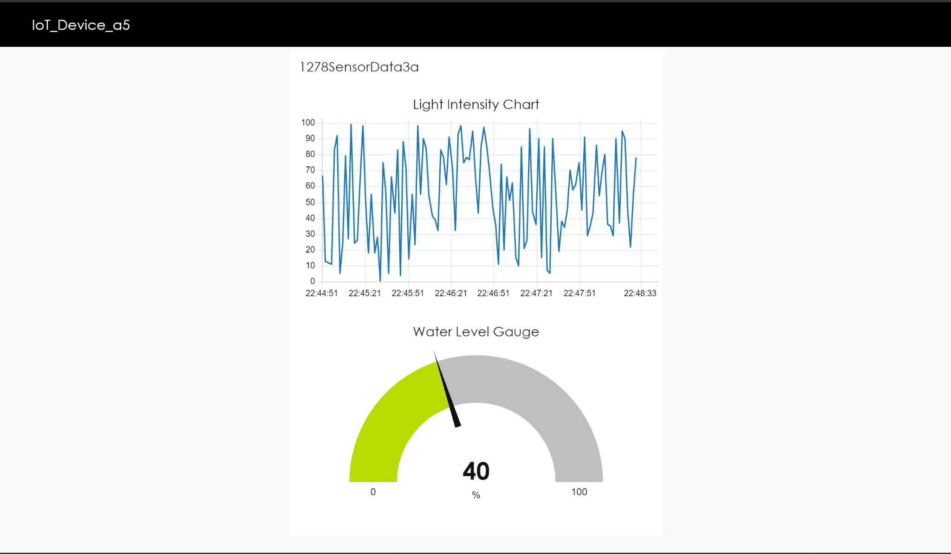

*Fig-2: Node-RED UI Dashboard*

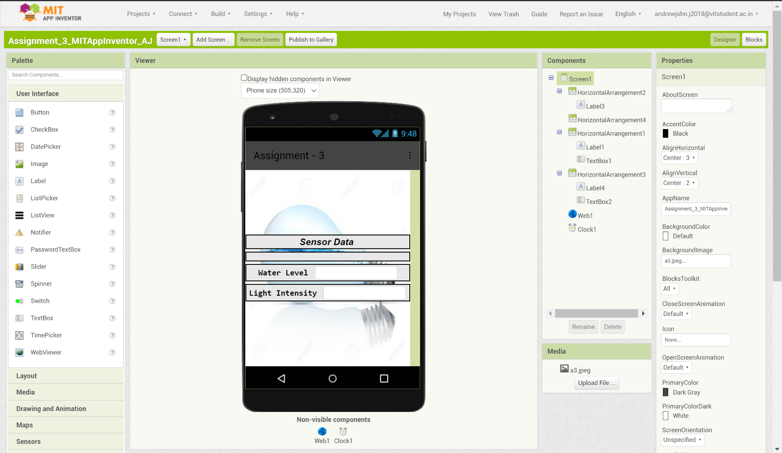

*Fig-3: MIT App Inventor Designer*

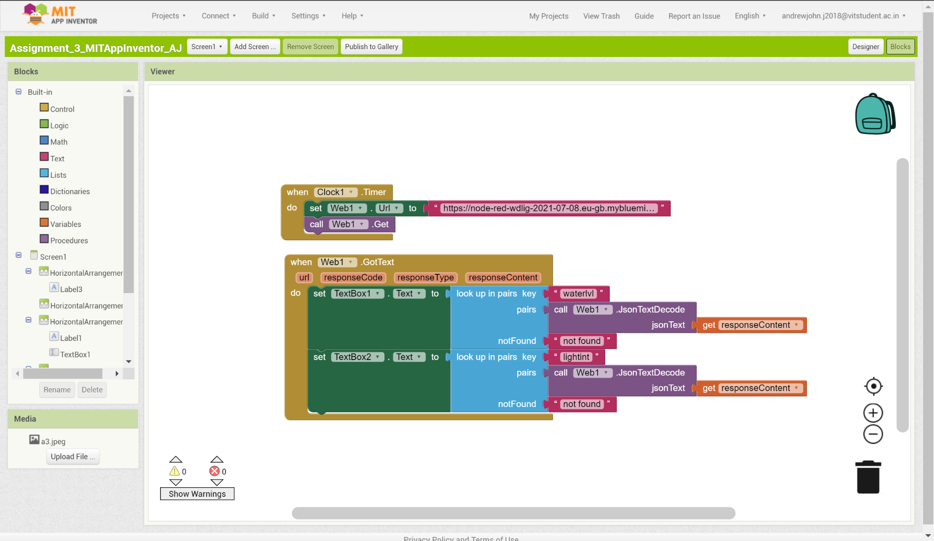

*Fig-4: MIT App Inventor Blocks*

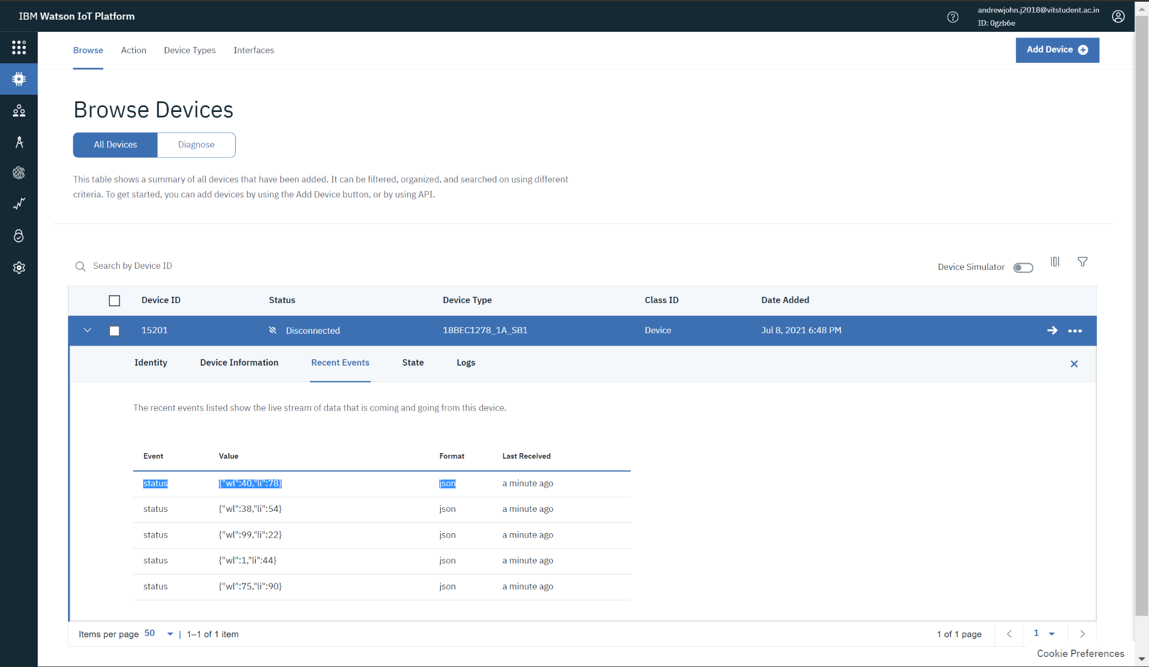

*Fig-5: IBM Watson Device*

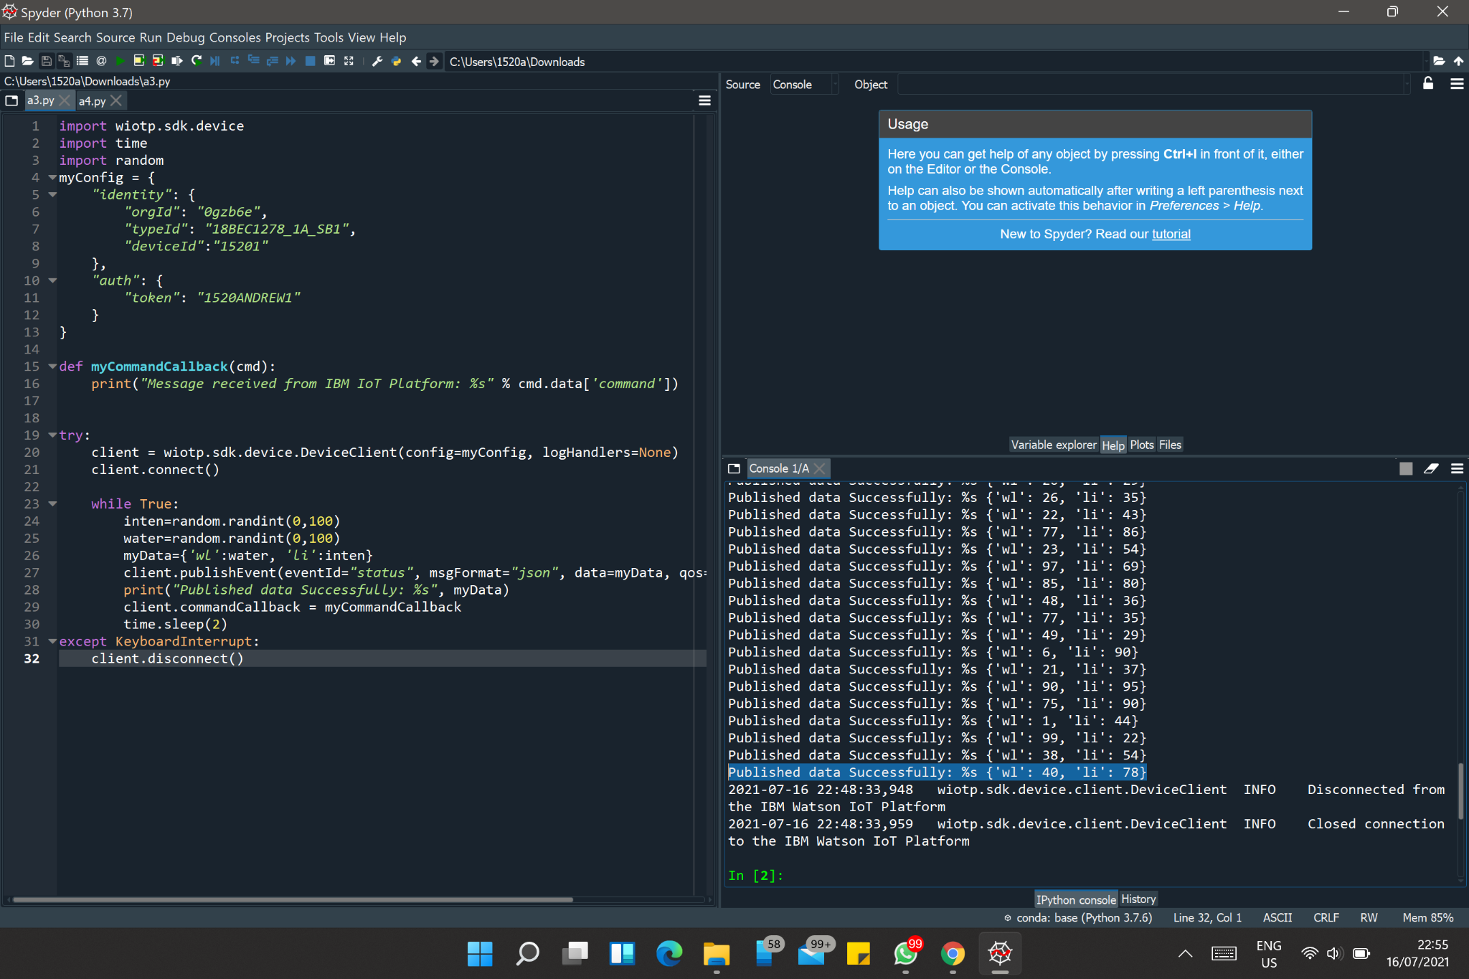

*Fig-6: Python Code*

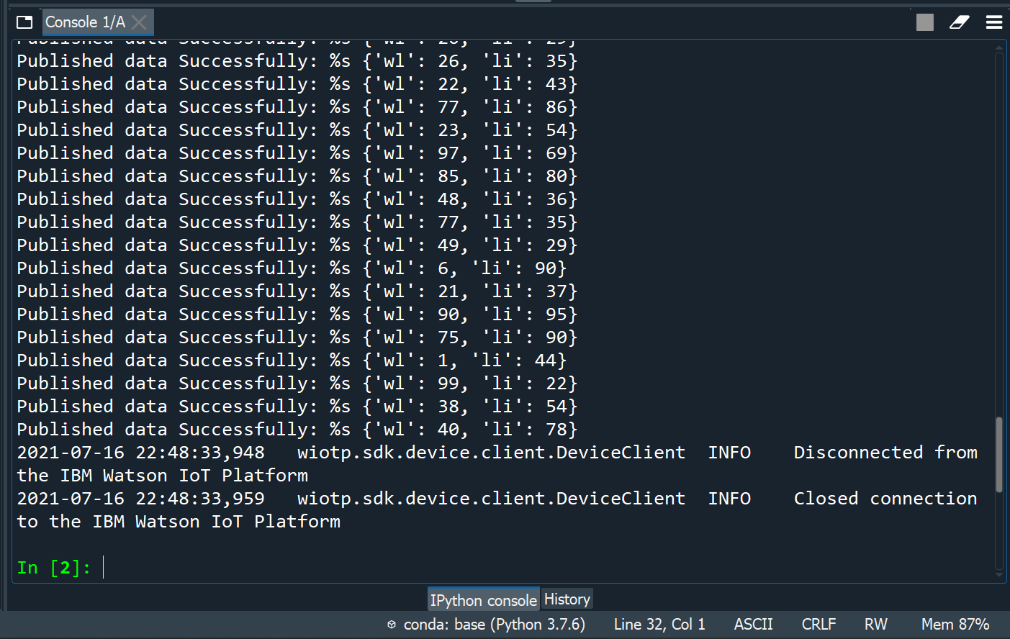

*Fig-7: Python Console*



*Fig-8: Node-RED URL*

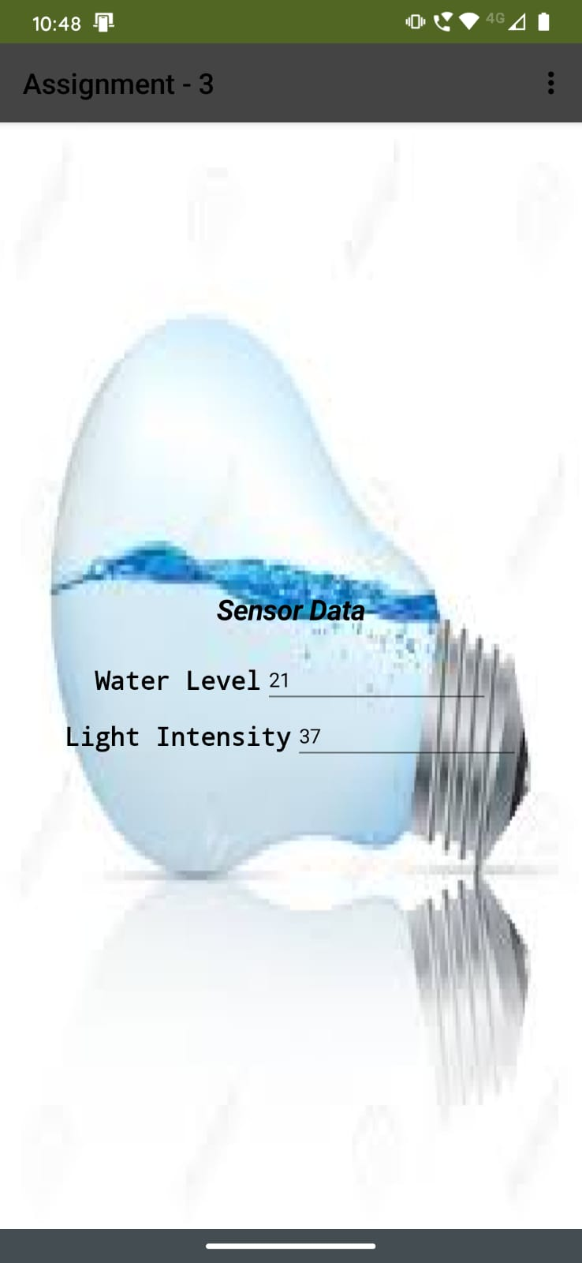

*Fig-9: MIT App Inventor APK App*